**Summary:**

We have read 6 research papers into which we have seen different methodologies used by different people in the field of communication between the deaf and the normal people. There are two types of systems used for the communication purpose.

* Wearable Communication Device
* Online Learning System

Wearable communication systems involves the glove based system which was invented 30 year ago and research is still continuing. E-learning environment is one of the most used techniques for educational purpose of Deaf and hard hearing person .Researches on the usage of the e-learning environment for hearing impaired students started from the year 2005 and still it is going on to make it more effective. With the advantages of different systems there are also some limitations of the above category systems which are discussed below. These system have different functionalities and methods and have different principles on to which they are working. Some of the systems are given below.

1. **Full Duplex Communication System for Deaf & Dumb People:**
2. **Extraction Method:** Segmentation
3. **Features Extraction:** Feature Vector on segmented image like fingertip etc.
4. **Gestures Classification:** Classification and matching of input.

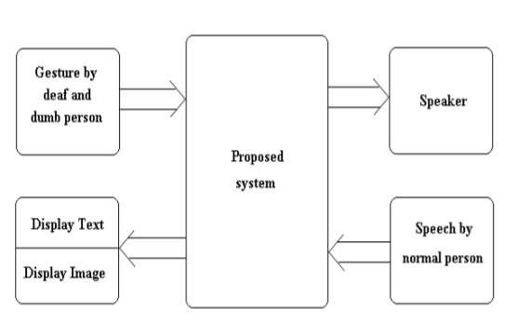

**Limitations:**

Use of Glove by the deaf and dumb person (no image processing)

Flex Sensors and gloves (external hardware)

**REFERENCES:**

Shraddha R. Ghorpade, Surendra K. Waghamare “Full Duplex Communication System for Deaf & Dumb People” International Journal of Emerging Technology and Advanced Engineering Website: www.ijetae.com (ISSN 2250-2459, ISO 9001:2008 Certified Journal, Volume 5, Issue 5, May 2015)

1. **HAND GESTURE RECOGNITION AND VOICE CONVERSION SYSTEM**

This System uses digital pattern given by the glove for every image to match and send it to RF transmitter and get text from transmitter and at the end change the text to voice

**Algorithm:**

Step 1:- start

Step 2:- read digital pattern from gloves

Step 3:- Send characters for corresponding patterns toRF transmitter

Step 4:- Receive text from transmitter via UARTreceiver pin

Step 5:- Display text on LCD which was enclosed withgestures ‘S’ and ‘.’

Step 6:- Send that data to emic module via UARTtransmitter pin

Step 7:- Text to voice conversion

Step 8:- Play voice output

**Limitations:**

Wireless Data-Glove and Metal Strips (Hardware)

Other hardware like Leaf switches based glove, CMOS camera

**REFERENCES:**

MONISHA.J, PRITHIBA.S “HAND GESTURE RECOGNITION AND VOICE CONVERSION SYSTEM”

International Journal of Emerging Technology in Computer Science & Electronics (IJETCSE) ISSN: 0976-1353 Volume 23 Issue 2 – JUNE 2016 (SPECIAL ISSUE)

1. **Handicom Using Touch Screen:**

A touch screen is an electronic visual display that the user can control through simple or multi-touch gestures by touching the screen with one or more fingers

**Limitations:**

Limited Database

Hand Wearable Device (Person without Hands Can’t Use it)

Touch Screen

Hardware like sensors LCD etc.

**REFERENCES:**

Sunitha K. A, Anitha Saraswathi.P, Aarthi.M, Jayapriya. K, Lingam Sunny “Deaf Mute Communication Interpreter- A Review” International Journal of Applied Engineering Research ISSN 0973-4562 Volume 11, Number 1 (2016) pp 290-296

1. **Smart Communication System for Deaf-Dumb People**

Finger Position

Hand Orientation By Accelerometer.

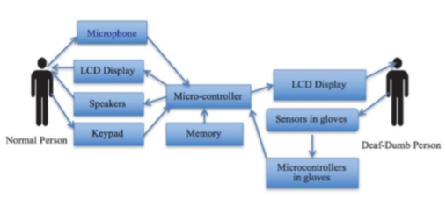

**Limitations:**

Accelerometer and Sensors (Motion Detector)

Hardware like Xbox 360, Kinect camera and sensor etc.

**REFERENCES:**

Mina M. Abdel-Masieh, Manuel M. Nasief, Maher M.Abdel-Aziz “Smart Communication System for Deaf- Dumb People” Int'l Conf. Embedded Systems, Cyber-physical Systems, & Applications | ESCS'17 |

1. **Wi-See Technology**

In Wi-see technology gesture recognition is done using conventional Wi-fi signals. The main advantage is that there is no instrumentation or sensing part used here. It is completely based on Doppler shift in frequency of Wi-Fi signals.

**Limitations:**

Wifi

Frequency Pattern for recognition of Alphabets.

Limited DataBase

**REFERENCES:**

Sunitha K. A, Anitha Saraswathi.P, Aarthi.M, Jayapriya. K, Lingam Sunny “Deaf Mute Communication Interpreter- A Review” International Journal of Applied Engineering Research ISSN 0973-4562 Volume 11, Number 1 (2016) pp 290-296